9073 Underwater Oasis puzzle (200)
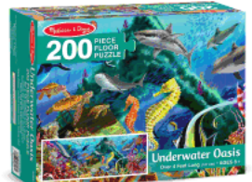

3858 Outer Space puzzle (100)

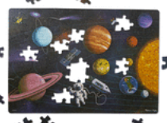

3476 Jungle Juniors puzzle (24)
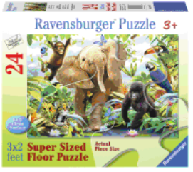

6088 Ocean Turtles puzzle (200)
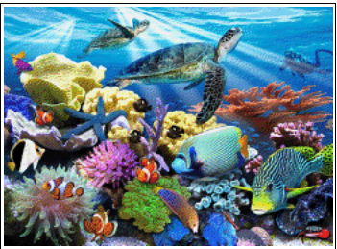

7200 Golden Gate puzzle (1000)
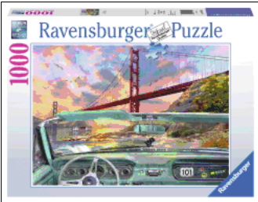

5491 Jungle Bird puzzle (1000)
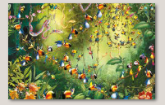

5407 Macaroons puzzle (1000)
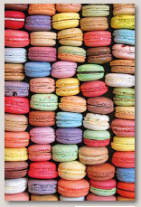

5357 Wine Gallery puzzle (1000)
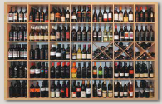

5403 Van Gogh – Starry Night puzzle (1000)
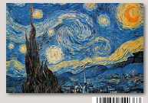

5498 Green Macaw puzzle (1000)
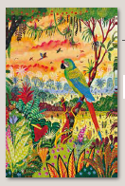

5467 Hummingbirds puzzle (1000)
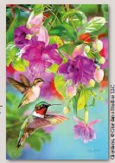

5468 Joyful Place puzzle (1000)
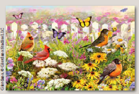

5469 Doors puzzle (1000)
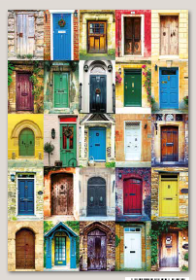

5487 Umbrellas puzzle (1000)
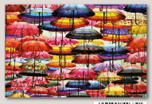

5488 Sea Urchins puzzle (1000)
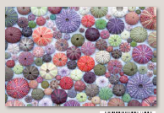

5509 Kahlo – Self Portrait with Monkeys puzzle (1000)
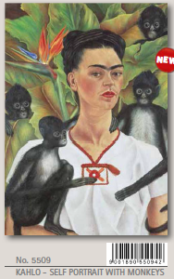

5511 Pasta puzzle (1000)
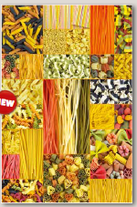

5527 Klimt – Lady with a Fan (1000)
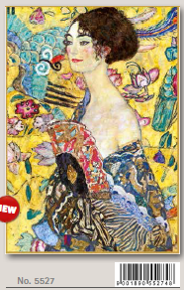

5520 Tiffany Magnolia & Iris puzzle (1000)
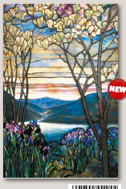

5663 Seashells puzzle (1000)
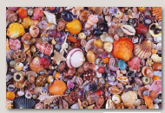

5698 Hokusai puzzle (1000)
